ESCAP/WMO WRD/TC.41/6
Typhoon Committee
41st Session
Chiang Mai, Thailand

Review of the 2008 Typhoon Season
Annual publications
(Item 6)

FROM MALAYSIA

1.0 Overview of tropical cyclones which have affected/impacted Member’s area since the last Typhoon Committee Session

1.1 Meteorological Assessment

There are sixteen tropical cyclones (tropical storm intensity or higher) developed over the west Pacific Ocean, South China Sea and Philippines region from 1 September 2007 to 31 December 2007 and another eighteen from 1 January 2008 to 1 November 2008. Table 1 shows the list of the fourteen (14) tropical cyclones that developed over the west Pacific Ocean and two (2) that developed over the northern Philippines region during 1 September 2007 to 31 December 2007. Table 2 shows the list of the ten (10) tropical cyclones that developed over the west Pacific Ocean, five (5) that developed over the Philippines region and three (3) that formed over the South China Sea region during 1 January 2008 to 31 October 2008. Nevertheless, there are only five (5) tropical cyclones from 1 September 2007 to 31 December 2007, and only three (3) from 1 January 2008 to 31 October 2008, as shown in bold in Table 1 and Table 2, which have some impacts on the weather in Malaysia, particularly on the rainfall as well as the coastal waters. The tail effects of these tropical cyclones had enhanced the afternoon convective activities and caused heavy and sometimes widespread rains over Malaysian region. Most of the other tropical cyclones are located far away from Malaysia and have less significant impacts on Malaysia. The tracks of the tropical cyclones that tracked close to Malaysian region are shown in Figure 1 for 1 September 2007 to 31 December 2007 and Figure 2. for 1 January 2008 to 31 October 2008.

The rain cloud clusters over the Malaysian region associated with the tropical cyclones, as shown in the satellite imageries in Figure 3 and Figure 4, indicate heavy and sometimes widespread rains over the region. These heavy and sometimes widespread rains are depicted in the daily rainfall charts of selected meteorological stations from September to November 2007 and May, September and October 2008 as shown in Figures 5a to 5i. Some of these charts may not show significant amount of rainfall as depicted by the corresponding satellite imageries as the heavy rains occurred not over but in the vicinities of these stations.

The number of tropical cyclone advisory issued by the Malaysian Meteorological Department is as shown in Table 3 for 1 September 2007 to 31 December 2007 and Table 4 for 1 January 2008 to 31 October 2008. The tables also shown the starting and ending dates for the advisory issued for each tropical cyclone. There are no tropical cyclone warning issued during both of the periods.

In comparison with previous years, most of this year tropical cyclones are quite a distant away from Malaysia region. They have no significant impacts on the weather over Malaysia. The usually dry, hot and hazy weather conditions during the southwest monsoon season (June to mid-September) had experienced more rainfall. As a result, the usual impacts of the trans-boundary haze pollution over Malaysia region were very much lessened.

Table 1 List of Tropical Cyclones and the date of their Birth, Death and Life Time from 1st September 2007 to 31st December 2007

No. | Tropical Cyclone Name (2007) | Birth | Death | Duration (Days)
1 | Fitow* | 29-Aug-07 | 8-Sep-07 | 10
2 | Danas* | 7-Sep-07 | 11-Sep-07 | 4
3 | Nari* | 13-Sep-07 | 17-Sep-07 | 3
4 | Wipha* | 16-Sep-07 | 19-Sep-07 | 3
5 | Francisco# | 23-Sep-07 | 25-Sep-07 | 1
6 | Lekima# | 30-Sep-07 | 2-Oct-07 | 2
7 | Krosa* | 1-Oct-07 | 8-Oct-07 | 6
8 | Haiyan* | 5-Oct-07 | 6-Oct-07 | 1
9 | Podul* | 5-Oct-07 | 7-Oct-07 | 2
10 | Lingling* | 11-Oct-07 | 15-Oct-07 | 3
11 | Kajiki* | 19-Oct-07 | 22-Oct-07 | 3
12 | Faxai* | 26-Oct-07 | 27-Oct-07 | 1
13 | Peipah* | 3-Nov-07 | 8-Nov-07 | 5
14 | Tapah* | 12-Nov-07 | 12-Nov-07 | 18 Hours
15 | Mitag* | 20-Nov-07 | 27-Nov-07 | 7
16 | Hagibis* | 20-Nov-07 | 27-Nov-07 | 6

Remarks: 1. Tropical cyclones that formed over

* west Pacific Ocean (14 cases)
# Philippines region (2 cases)
@ South China Sea region (0 cases)

2. Tropical cyclones that have impacts on the weather in Malaysia are shown in bold.
Table 2 List of Tropical Cyclones and the date of their Birth, Death and Life Time from 1st January 2008 to 31st October 2008

No. | Tropical Cyclone Name (2008) | Birth | Death | Duration (Days)
1 | Neoguri@ | 15-Apr-08 | 19-Apr-08 | 4
2 | Rammasun* | 7-May-08 | 13-May-08 | 5
3 | Matmo# | 15-May-08 | 17-May-08 | 1
4 | Halong@ | 16-May-08 | 20-May-08 | 4
5 | Nakri* | 27-May-08 | 3-Jun-08 | 7
6 | Fengshen* | 19-Jun-08 | 25-Jun-08 | 6
7 | Kalmaegi# | 15-Jul-08 | 20-Jul-08 | 5
8 | Fung-Wong* | 25-Jul-08 | 29-Jul-08 | 4
9 | Kammuri# | 5-Aug-08 | 7-Aug-08 | 2
10 | Phanfone* | 10-Aug-08 | 11-Aug-08 | 1
11 | Vongfong* | 15-Aug-08 | 17-Aug-08 | 2
12 | Nuri* | 18-Aug-08 | 23-Aug-08 | 5
13 | Sinlaku# | 8-Sep-08 | 21-Sep-08 | 12
14 | Hagupit* | 19-Sep-08 | 25-Sep-08 | 5
15 | Jangmi* | 24-Sep-08 | 1-Oct-08 | 6
16 | Mekkhala@ | 29-Sep-08 | 30-Sep-08 | 1
17 | Higos# | 30-Sep-08 | 4-Oct-08 | 4
18 | Bavi* | 19-Oct-08 | 20-Oct-08 | 1

Remarks: 1. Tropical cyclones that formed over

* west Pacific Ocean (10 cases)
# Philippines region (5 cases)
@ South China Sea region (3 cases)

2. Tropical cyclones that have impacts on the weather in Malaysia are shown in bold.

Table 3 Number of Tropical Cyclone Advisory Issued from 1st September 2007 to 30thNovember 2007

No. | Name | Category | Advisory Issued | Start Date |  | End Date
1 | Francisco | Storms | 7 | 23/09/2007 | - | 25/09/2007
2 | Lekima | Typhoon | 6 | 02/10/2007 | - | 04/10/2007
 |  | Storms | 8 | 30/09/2007 | - | 04/10/2007
3 | Krosa | Typhoon | 13 | 04/10/2007 | - | 07/10/2007
 |  | Storms | 6 | 05/10/2007 | - | 09/10/2007
4 | Peipah | Typhoon | 8 | 05/11/2007 | - | 07/11/2007
 |  | Storms | 11 | 04/11/2007 | - | 09/11/2007
5 | Hagibis | Typhoon | 8 | 22/11/2007 | - | 23/11/2007
 |  | Storms | 12 | 19/11/2007 | - | 21/11/2007
6 | Mitag | Typhoon | 10 | 24/11/2007 | - | 27/11/2007
 |  | Storms | 5 | 27/11/2007 | - | 28/11/2007

Table 4 Number of Tropical Cyclone Advisory Issued from 1st January 2008 to 31st October 2008

No. | Name | Category | Advisory Issued | Start Date |  | End Date
1 | Neoguri | Typhoon | 11 | 16/04/2008 | - | 19/04/2008
 |  | Storms | 6 | 16/04/2008 | - | 20/04/2008
2 | Rammasun | Typhoon | 10 | 08/04/2008 | - | 10/04/2008
 |  | Storms | 7 | 09/04/2008 | - | 12/04/2008
3 | Halong | Typhoon | 1 | 17/05/2008 | - | -
 |  | Storms | 8 | 17/05/2008 | - | 18/05/2008
4 | Fengshen | Typhoon | 8 | 20/06/2008 | - | 22/06/2008
 |  | Storms | 10 | 19/06/2008 | - | 24/06/2008
5 | Fung Wong | Typhoon | 5 | 27/07/2008 | - | 28/07/2008
 |  | Storms | 3 | 28/07/2008 | - | 29/07/2008
6 | Kammuri | Storms | 14 | 04/08/2008 | - | 07/08/2008
7 | Nuri | Typhoon | 9 | 19/08/2008 | - | 22/08/2008
 |  | Storms | 8 | 19/08/2008 | - | 23/08/2008
8 | 14 W | Storms | 4 | 27/08/2008 | - | 28/08/2008
9 | Sinlaku | Typhoon | 12 | 09/09/2008 | - | 13/09/2008
10 | Hagupit | Typhoon | 9 | 20/09/2008 | - | 24/09/2008
 |  | Storms | 8 | 22/09/2008 | - | 24/09/2008
11 | Jangmi | Typhoon | 14 | 25/09/2008 | - | 29/09/2008
 |  | Storms | 6 | 29/09/2008 | - | 01/10/2008
12 | Makkhala | Typhoon | 1 | 29/09/2008 | - | 29/09/2008
 |  | Storms | 6 | 29/09/2008 | - | 01/10/2008
13 | Higos | Typhoon | 1 | 01/10/2008 | - | 01/10/2008
 |  | Storms | 13 | 30/09/2008 | - | 05/10/2008
14 | 22W | Storms | 2 | 14/10/2008 | - | 05/10/2008

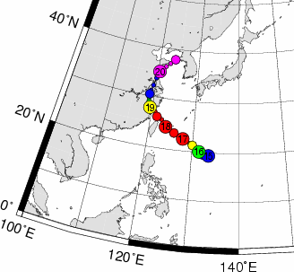 |  | 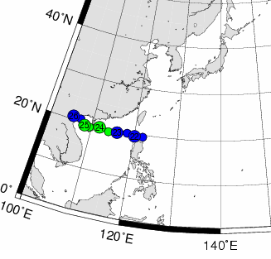
WIPHA |  | FRANCISCO
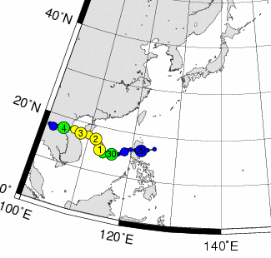 |  | 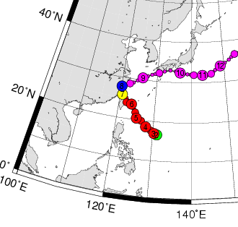
LEKIMA |  | KROSA
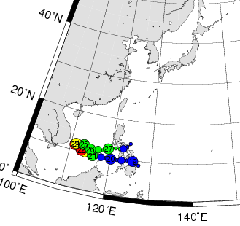
HAGIBIS

Figure 1 Tracks of the five (5) tropical cyclones closest to Malaysia during 1 September 2007 to 31 December 2007. The number in the circle represents the date of occurrence of the tropical cyclones.

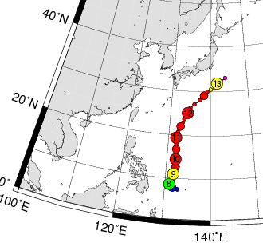 |  | 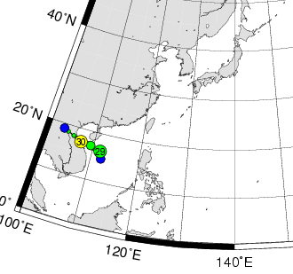
RAMMASUN |  | MEKKHALA
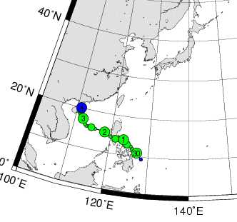
HIGOS

Figure 2 Tracks of the three (3) tropical cyclones closest to Malaysia during 1 January 2008 to 31 October 2008. The number in the circle represents the date of occurrence of the tropical cyclones.

Wipha (16/09/2007) Francisco (23/09/2007)

Lekima (30/09/2007) Krosa (06/10/2007)

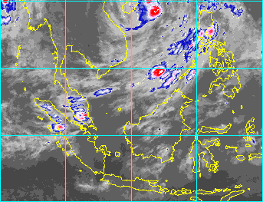
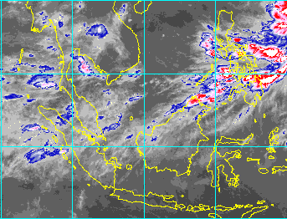
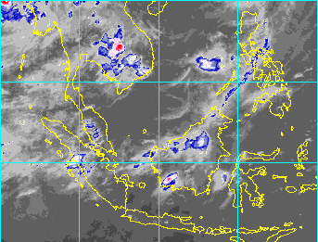

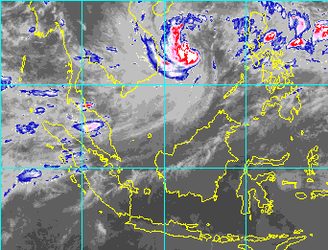
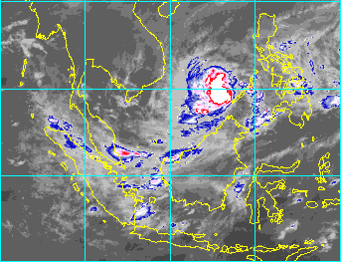

Hagibis (21/11/2007)

Figure 3 Satellite Imageries indicate the rain cloud clusters associated with some of the selected tropical cyclones over the Malaysian region during 1 September 2007 to 31 December 2007.

Rammasun (09/05/2008) Mekkhala (29/09/2008)

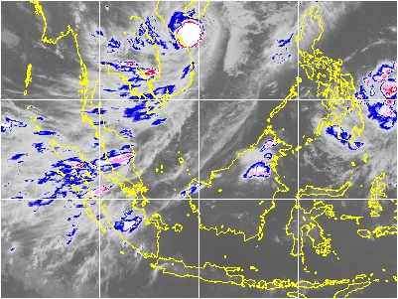
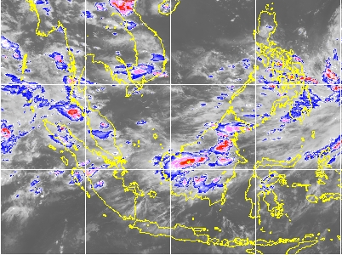

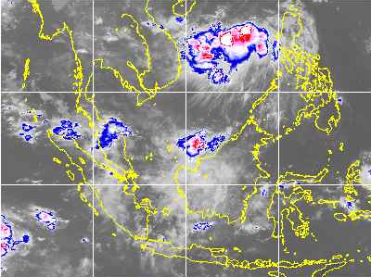

Higos (02/10/2008)

Figure 4 Satellite Imageries indicate the rain cloud clusters associated with some of the selected tropical cyclones over the Malaysian region during 1 January 2008 to 1 November 2008.

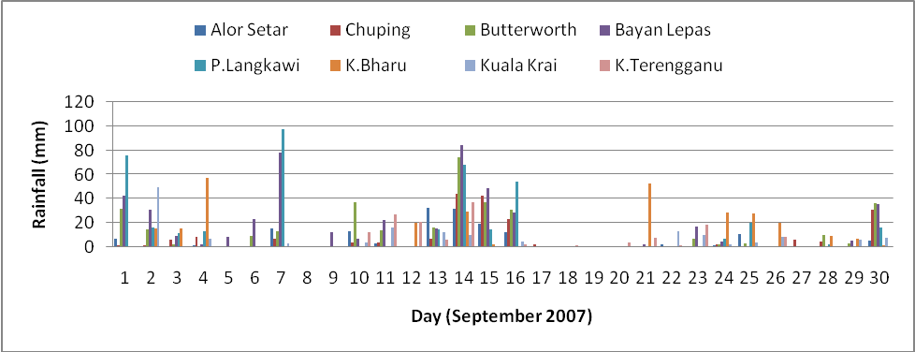
Figure 5a Daily rainfall chart recorded by selected meteorological stations in Peninsular Malaysia for September 2007: Tropical Storm Francisco (23/9/07-25/9/07) and Severe Tropical storm Lekima (30/09/07-02/10/07).

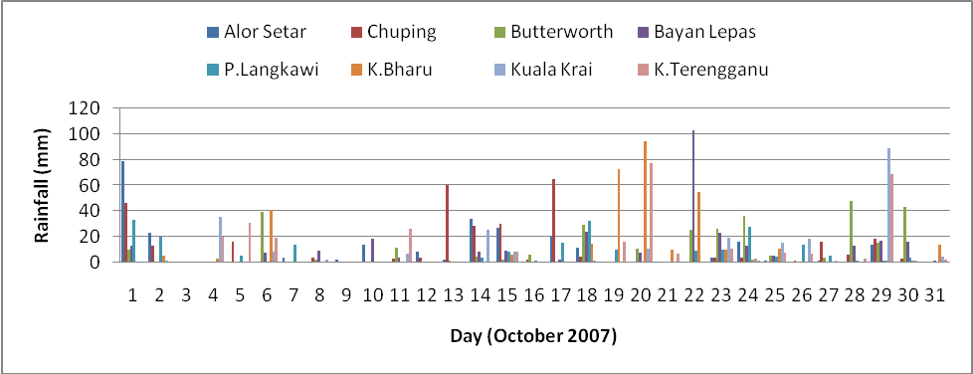

Figure 5b Daily rainfall chart recorded by selected meteorological stations in Peninsular Malaysia for October 2007: Typhoon Krosa (1/10/07-08/10/07).

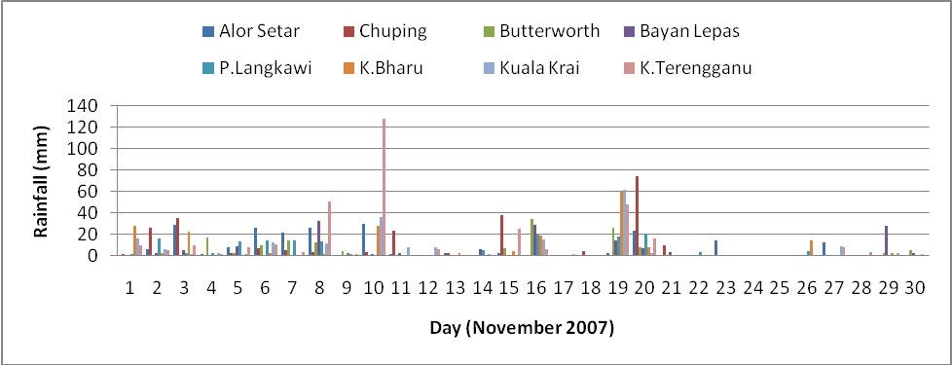

Figure 5c Daily rainfall chart recorded by selected meteorological stations in Peninsular Malaysia for November 2007: Typhoon Hagibis (20/11/07-27/11/07).

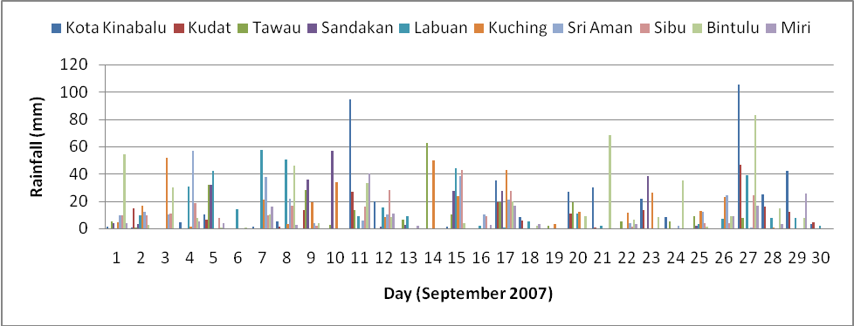

Figure 5d Daily rainfall chart recorded by selected meteorological stations in East Malaysia for September 2007: Typhoon Wipha (16/9/07-19/9/07).

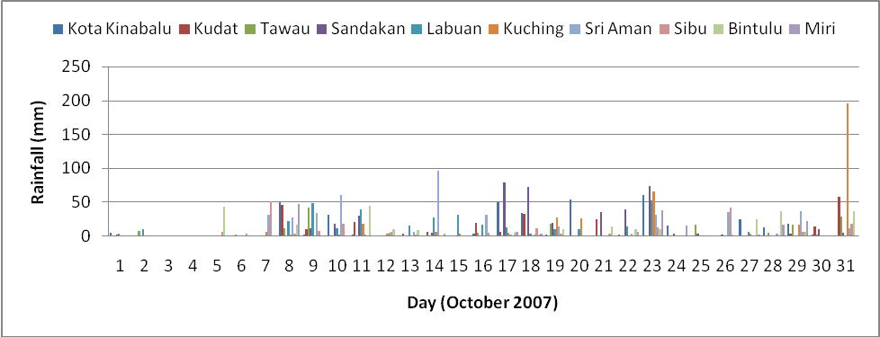

Figure 5e Daily rainfall chart recorded by selected meteorological stations in East Malaysia for October 2007: Typhoon Krosa (1/10/07-08/10/07).

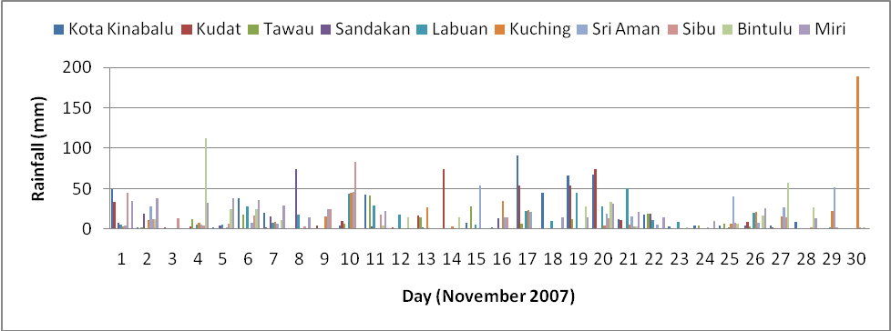

Figure 5f Daily rainfall chart recorded by selected meteorological stations in East Malaysia for November 2007: Typhoon Hagibis (20/11/07-27/11/07).

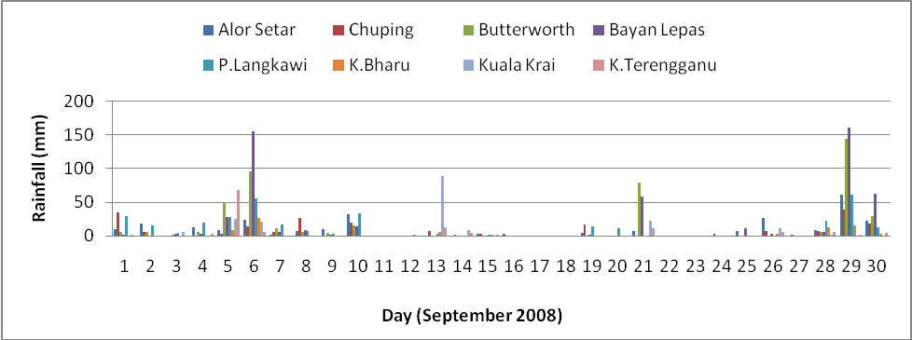

Figure 5g Daily rainfall chart recorded by selected meteorological stations in Peninsular Malaysia for September 2008: Severe Tropical Storm Mekkhala (29/09/08-30/09/08).

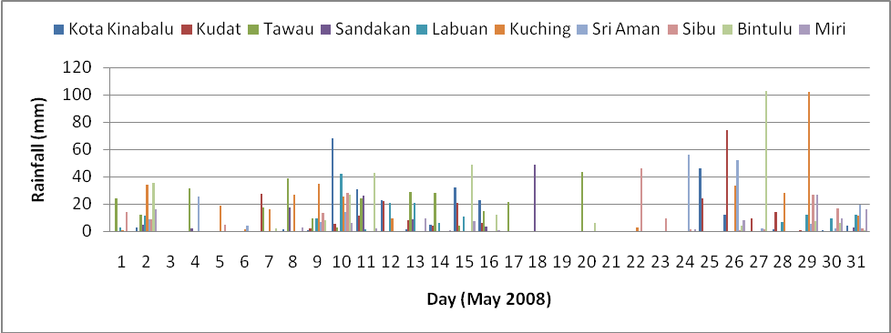

Figure 5h Daily rainfall chart recorded by selected meteorological stations in East Malaysia for May 2008: Typhoon Rammasun (07/05/08-13/05/08).

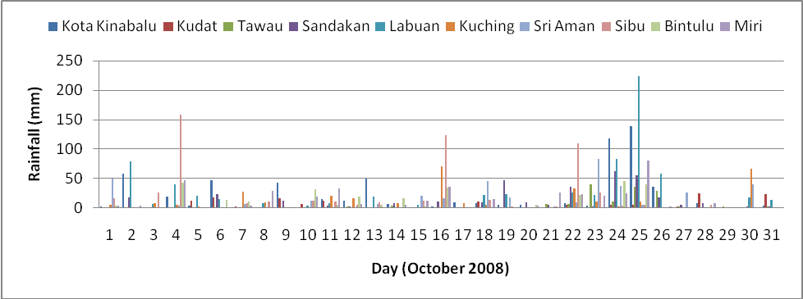

Figure 5i Daily rainfall chart recorded by selected meteorological stations in East Malaysia for October 2008: Tropical Storm Higos (30/09/08-04/10/08).

1.2 Hydrological Assessment

During the 2007 North-East monsoon, the northern and east region of the Peninsular Malaysia namely Kedah, Kelantan, Pahang and some part of Johor experienced severe flood due to prolong heavy rainfall events. However, the worst floods occurred in the Pahang river basin in the district of Temerloh, Pekan, Rompin, Mentakap and Kuantan for almost two weeks. Meanwhile, the Golok river basin in Kelantan experienced with floods in the period of 18-28 December 2007. Table 5 shows summary of flood occurrences in 2007 north-east monsoon. Figure 6(a), 6(b) and 6(c) shows the respective flooded areas in the Johor, Pahang, and Kelantan river basin that derived using Radarsat earth observation satellite during the period mentioned.

Table 5 Summary of flood events in 2007 North-East Monsoon

State/River Basin | Period of Rainfall  (Dec. 2007) | Date of Peak Flood (2007) | Average Rainfall  (mm) | Highest  Recorded Daily Rainfall  (mm) | Estimated Area of Flood Extent (Hect.)
Muda River, Kedah | 5-17 | Dec. 20/26.10m @ Jeniang | 199 | 135 | -
Golok River, Kelantan | 5-21 | Dec. 16/10.63m @ Rantau Panjang | 801 | 420 | 45,000
Pahang River, Pahang | 5-15 | Dec. 12/54.28m @ Sg. Yap  Dec. 13/34.02m @ Temerloh  Dec. 15/22.47m @ Lubok Paku | 385 | 261 | 36,000
Muar River, Johor | 5-22 | Dec. 10/11.94m @ Segamat  Dec.12/10.20m @ Buloh kasap | 398 | 217 | 40,000

The estimated total cost of the flood damages is RM316 million. Approximately 36,143 people were evacuated and given shelter in relief centres in Pahang and Kelantan. The death toll during this flood was 22 persons. The worst affected areas were areas along major rivers such as Sg Pahang, Sungai Muar and Sungai Golok.

Figure 6(a) Flood Extent Map of Johor

Figure 6(b) Flood Extent Map of Pahang

Figure 6(c) Flood Extent Map of Kelantan

